Que 1 →

● Create one IAM user and one IAM Group using Terraform.

● Make sure you will use variables for names of IAM users and Group.

● Note: - Below files are required. –

**providers.tf**

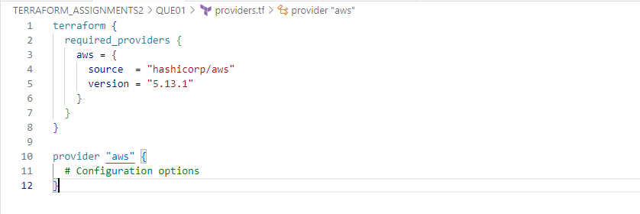

**main.tf –**

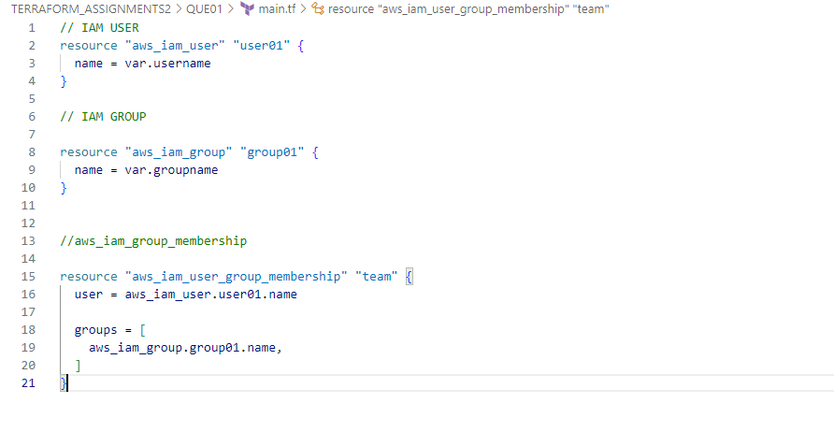

**variables.tf –**

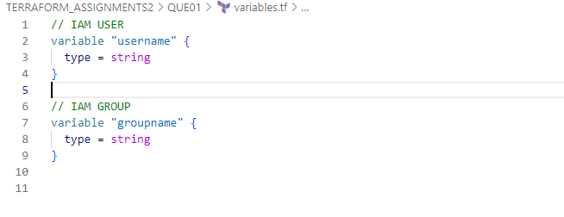

**esmail_custom.tfvars –**

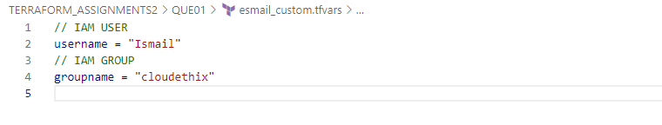

**Result –**

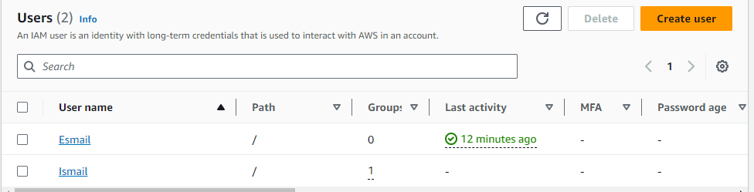

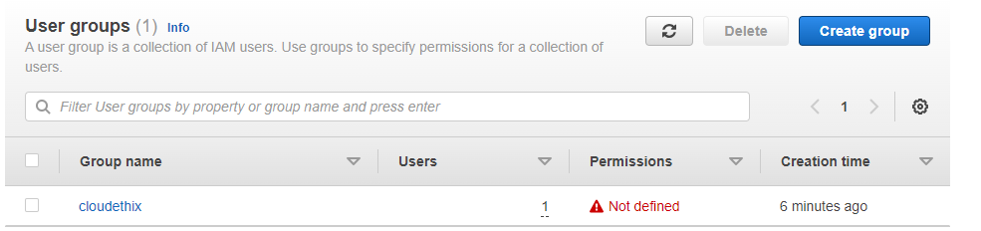

Que 2 →

● Create one EC2 Instance and Elastic IP using Terraform and Map elastic IP with EC2 instance.

● Also please make sure you will use a combination of both variables in the main.tf file.

* i.e. local and variable from variables.tf and custom.tfvars file.

● Also use output values to print EC2 instances Public DNS name, Private DNS name, Private IP and Public IP.

● Note: -

* Here you will require one locals in the main.tf file.
* Also, four output values in the main.tf file

Providers.tf

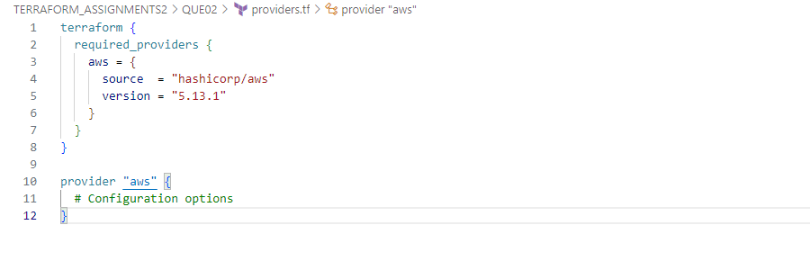

**Main.tf –**

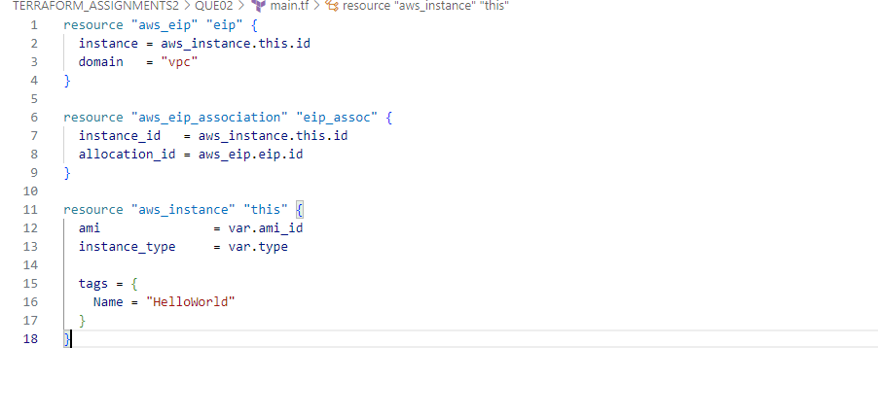

**Variable.tf –**

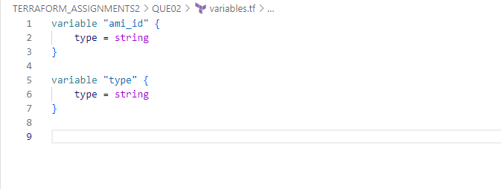

**Terraform.tfvars –**

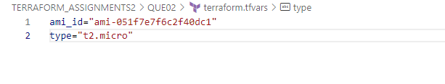

**Result**

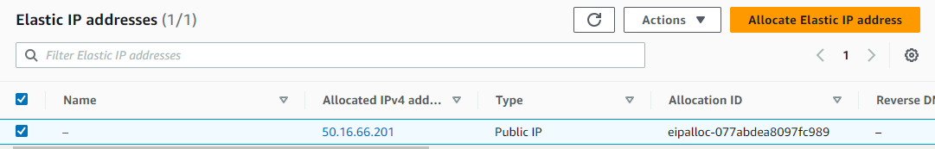

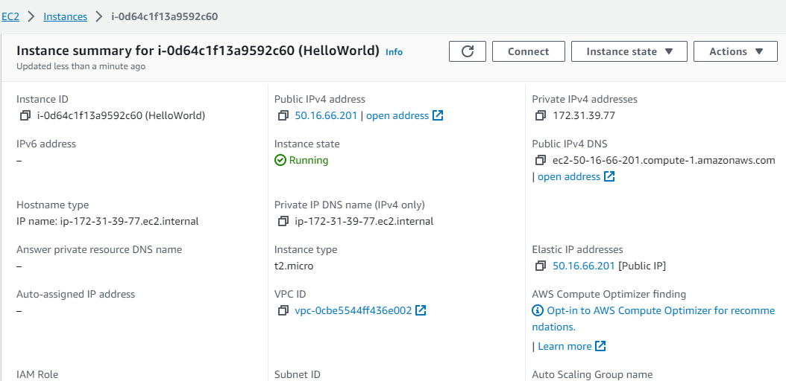

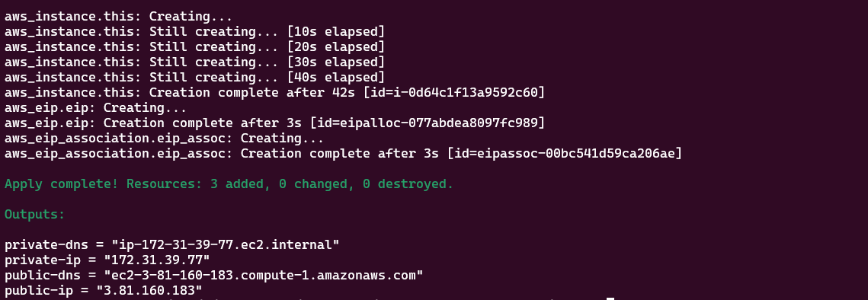

Que 3 →

● Create AWS VPC with Terraform.

● Please follow the given link for more on AWS VPC creation.

1. Create a VPC

2. Create 2 Public Subnet & Create 2 Private Subnet

3. Create IGW (Internet Gateway) & Attach to the VPC

4. Create Public and Private Route Table

5. Add IGW in Public Route table (0.0.0.0/0) 6. Add Public Subnet (1a & 1b) in Route table

7. Create a NAT Gateway in Public Subnet

8. Add NAT GW into the Private Route Table

9. Add Private Subnet in Private Route Table

● Link: -

https://varunmanik1.medium.com/how-to-create-aws-vpc-in-10- steps-less-than-5-min-a49ac12064aa

● Note: -

○ Try to create VPC manually to understand the concepts and then go for Terraform automation.

Providers.tf

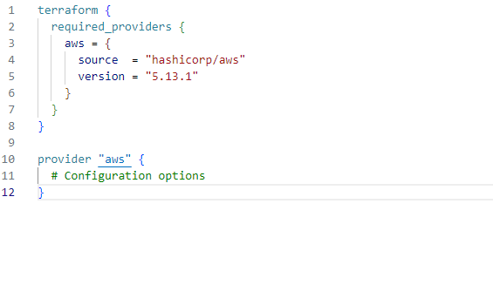

**Main.tf**

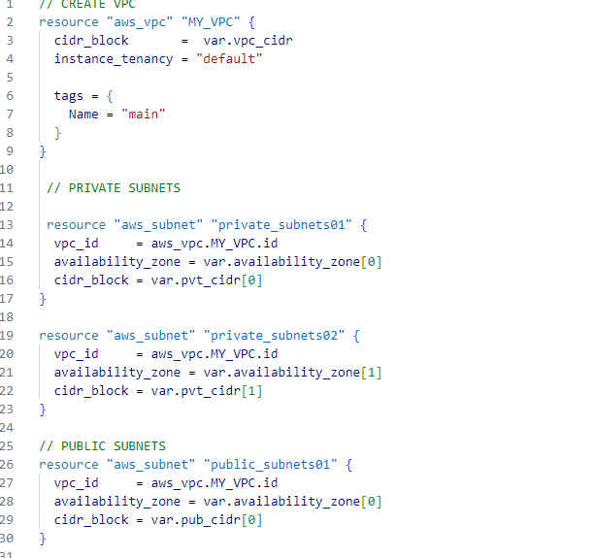

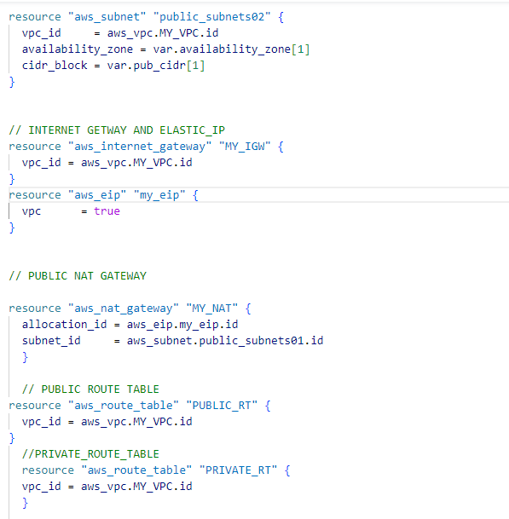

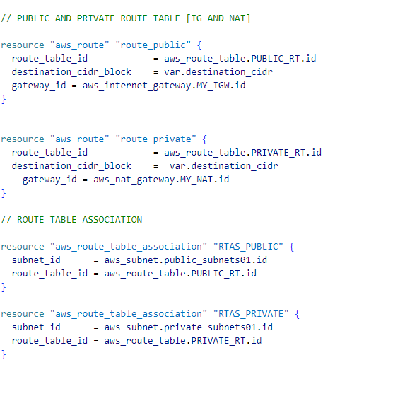

**Variable.tf**

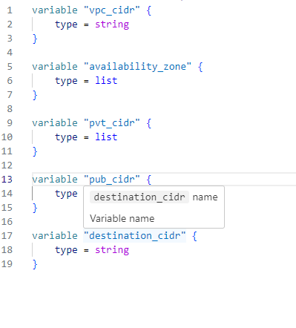

**Terraform.tfvars**

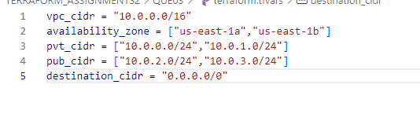

**VPC**

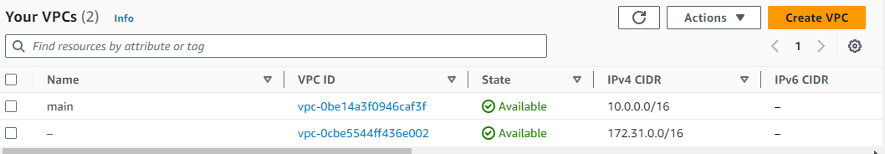

**Subnets**

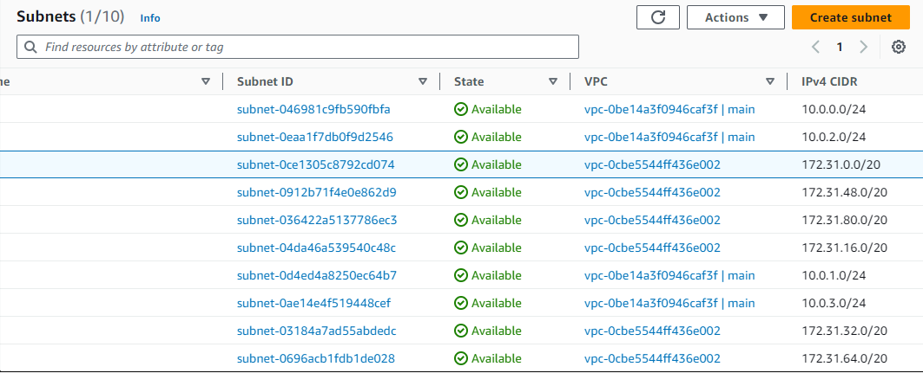

**Internet Gateway**

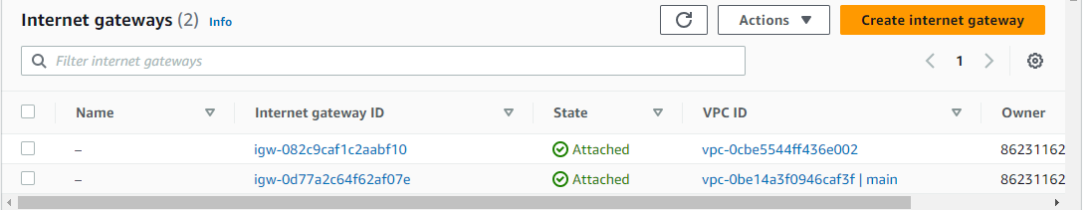

**Route Table**

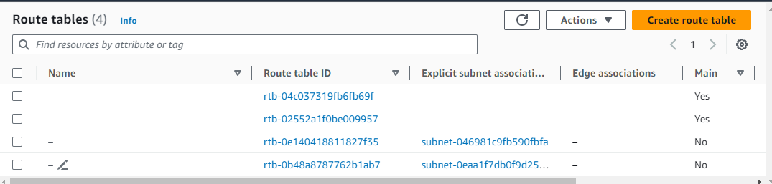

**NAT gateway**

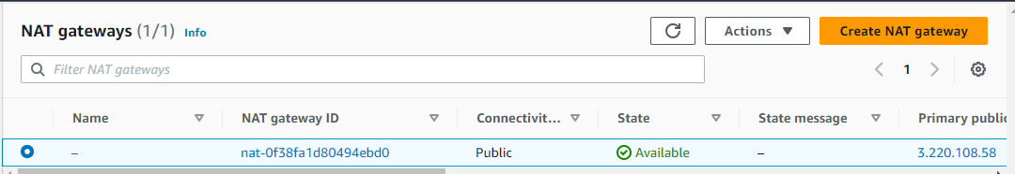

**Que 4 →**

● Create EC2 instance one of the public Subnets of VPC that you have created & Validate your Connection using ssh

● For this You need to create below AWS resources using Terraform.

1. EC2 Instance.

2. SSH Key

3. Security Group.

● Note: -

○ Attach SSH key and Security Group to EC2 Instance using attribute reference.

○ Then try to access it from an EC2 instance using the SSH key that you have created

Providers.tf

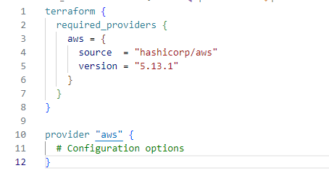

Main.tf

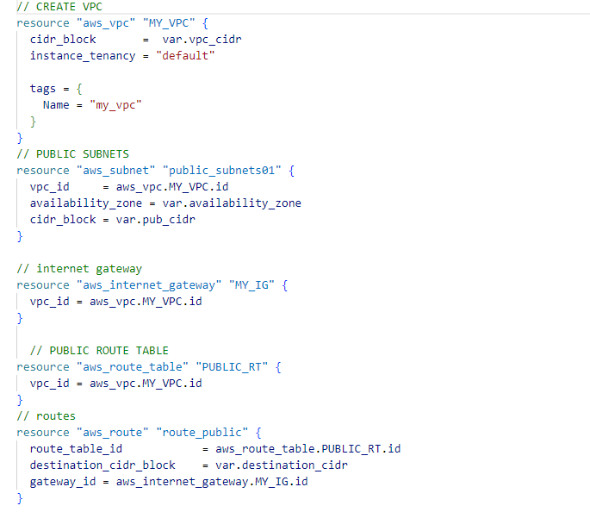

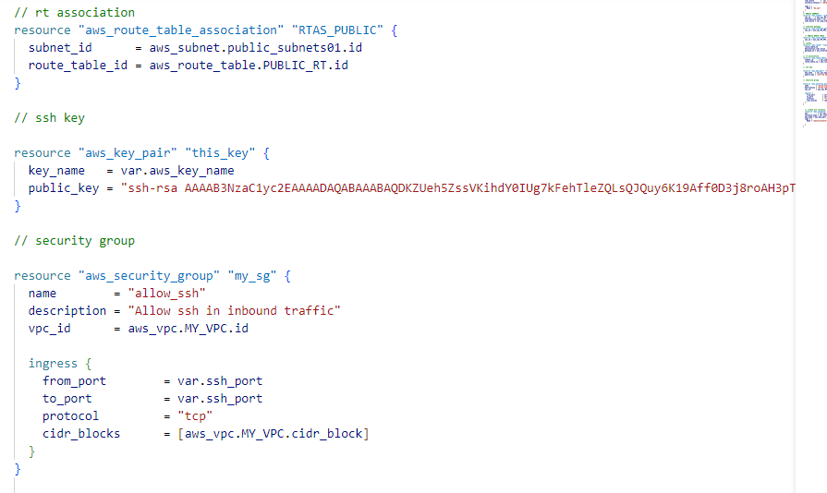

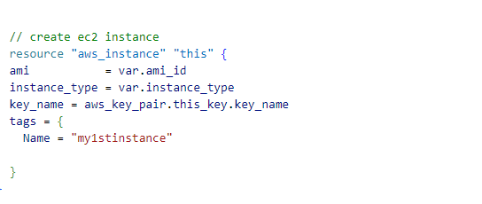

Variables.tf

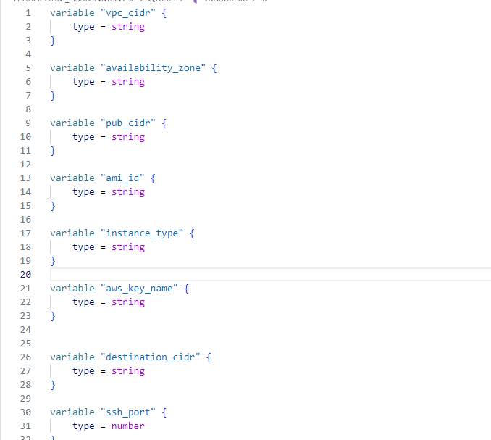

Terraform.tfvars

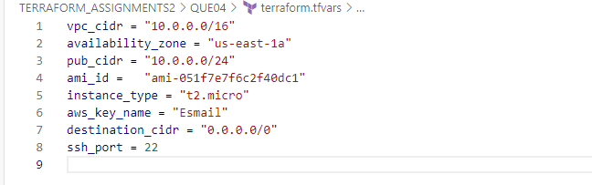

**KAY PAIR**

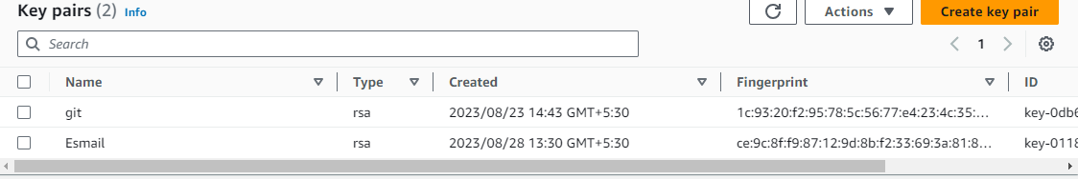

**Security Group**

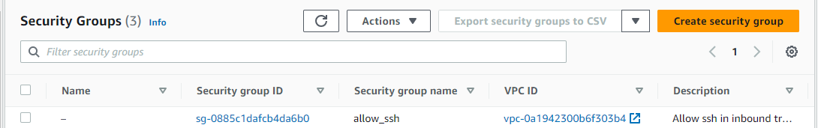

**Instance**

